Assignment 4

M Ahsan Jamshaid BSE173086

Jerrold Sigamony BSE173054

Usama Yasin BSE173078

**Code:**

public String ConvocationManagement(int credithours,float gpa,int semester)

{

String var="Null";

if(gpa<2 && semester>13 || semester>13 && credithours<152)

{

var= "not applicable";

}

else if(gpa>=2 && gpa<=4 && semester>=8 && semester<=14 && credithours>152)

{

var= "Qualified";

}

else if(semester<8 || gpa<2 || credithours<152)

{

var= "disqualified";

}

return var;

}

**Code Description:**

There are three categories in which students lie; Qualified, Disqualified, and Not Applicable. Students lie in these categories concerning their departments criteria. There are three departments; Computer Science (CS), Mechanical Engineering (ME), Electrical Engineering (EE). For CS the criteria are set that student must be having CGPA of greater than 2.0, minimum credit hours should be equal to 152 and maximum semesters equals to 14. For ME the criteria are set that student must be having CGPA of greater than 2.0, minimum credit hours should be equal to 156 and a maximum semester spent equals 14. For EE the criteria are set that student must be having CGPA of greater than 2.0, minimum credit hours should be equal to 160 and a maximum semester spent equals 14.

**MCDC**

**Statement no 1:**

(gpa<2 && semester>13 || semester>13 && credithours<152)

|  |  |  |  |
| --- | --- | --- | --- |
| gpa | semester | credithours | output |
| T | T | T | T |
| T | T | F | T |
| T | F | T | F |
| T | F | F | F |
| F | T | T | T |
| F | T | F | F |
| F | F | T | F |
| F | F | F | F |

**With input values:**

|  |  |  |  |
| --- | --- | --- | --- |
| gpa | semester | credithours | output |
| 1 | 14 | 120 | not applicable |
| 0 | 15 | 152 | not applicable |
| 1.5 | 2 | 151 | disqualified |
| 1.3 | 3 | 153 | disqualified |
| 2 | 16 | 150 | not applicable |
| 3 | 15 | 155 | disqualified |
| 4 | 5 | 140 | disqualified |
| 2.5 | 4 | 160 | Qualified |

**Statement no 2:**

(gpa>=2 && gpa<=4 && semester>=8 && semester<=14 && credithours>152

|  |  |  |  |
| --- | --- | --- | --- |
| gpa | semester | credithours | output |
| T | T | T | T |
| T | T | F | F |
| T | F | T | F |
| T | F | F | F |
| F | T | T | F |
| F | T | F | F |
| F | F | T | F |
| F | F | F | F |

**With input values:**

|  |  |  |  |
| --- | --- | --- | --- |
| gpa | semester | credithours | output |
| 2 | 8 | 153 | T |
| 3 | 9 | 130 | F |
| 4 | 1 | 155 | F |
| 2.5 | 2 | 120 | F |
| 0 | 10 | 156 | F |
| 1 | 11 | 152 | F |
| 0.5 | 15 | 157 | F |
| 1.5 | 5 | 123 | F |

**Statement no 3:**

(semester<8 || gpa<2 || credithours<152)

|  |  |  |  |
| --- | --- | --- | --- |
| gpa | semester | credithours | output |
| T | T | T | T |
| T | T | F | F |
| T | F | T | F |
| T | F | F | F |
| F | T | T | F |
| F | T | F | F |
| F | F | T | F |
| F | F | F | F |

**With input values:**

|  |  |  |  |
| --- | --- | --- | --- |
| gpa | semester | credithours | output |
| 2 | 8 | 153 | T |
| 3 | 9 | 130 | F |
| 4 | 1 | 155 | F |
| 2.5 | 2 | 120 | F |
| 0 | 10 | 156 | F |
| 1 | 11 | 152 | F |
| 0.5 | 15 | 157 | F |
| 1.5 | 5 | 123 | F |

**Control Flow Graph :**

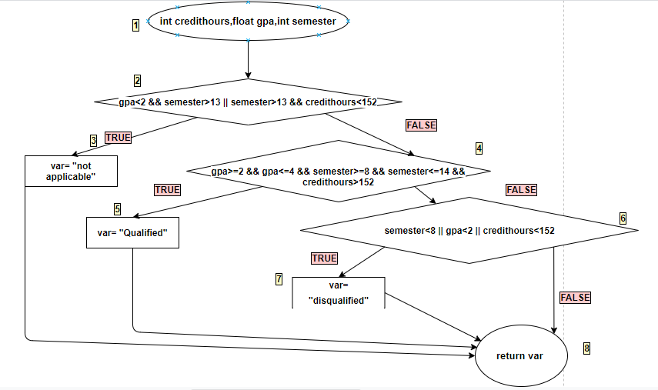

**Path Predicate Expressions:**

|  |  |  |
| --- | --- | --- |
| Number | Path | Path Predicate Expression |
| 1 | 1 -> 2 -> 3 ->8 | gpa<2 && semester>13 || semester>13&& credithours<152 |
| 2 | 1 -> 2 -> 4 -> 5 -> 8 | gpa<2 && semester>13 || semester>13&& credithours<152, gpa>=2 && gpa<=4 && semester>=8 && semester<=14 && credithours>152 |
| 3 | 1 -> 2 -> 4 -> 6 -> 7 -> 8 | gpa<2 && semester>13 || semester>13&& credithours<152, gpa>=2 && gpa<=4 && semester>=8 && semester<=14 && credithours>152, semester<8 || gpa<2 || credithours<152 |
| 4 | 1 -> 2 -> 4 -> 6 -> 8 | gpa<2 && semester>13 || semester>13&& credithours<152, gpa>=2 && gpa<=4 && semester>=8 && semester<=14 && credithours>152, semester<8 || gpa<2 || credithours<152 |

**Test Oracle:**

|  |  |  |  |  |  |  |
| --- | --- | --- | --- | --- | --- | --- |
| **No** | **Input** | | | **Path** | **Actual Output** | **Expected Output** |
|  | gpa | semester | credithours |  |  |  |
| 1 | 1 | 14 | 153 | 1 -> 2 -> 3 ->8 | not applicable | not applicable |
| 2 | 3 | 8 | 150 | 1 -> 2 -> 4 -> 5 -> 8 | Qualified | Qualified |
| 3 | 1 | 1 | 140 | 1 -> 2 -> 4 -> 6 -> 7 -> 8 | disqualified | disqualified |
| 4 | 0 | 0 | 0 | 1 -> 2 -> 4 -> 6 -> 8 | disqualified | disqualified |